# Proyecto 3

## Respuestas de API en POSTMAN

### Get Products

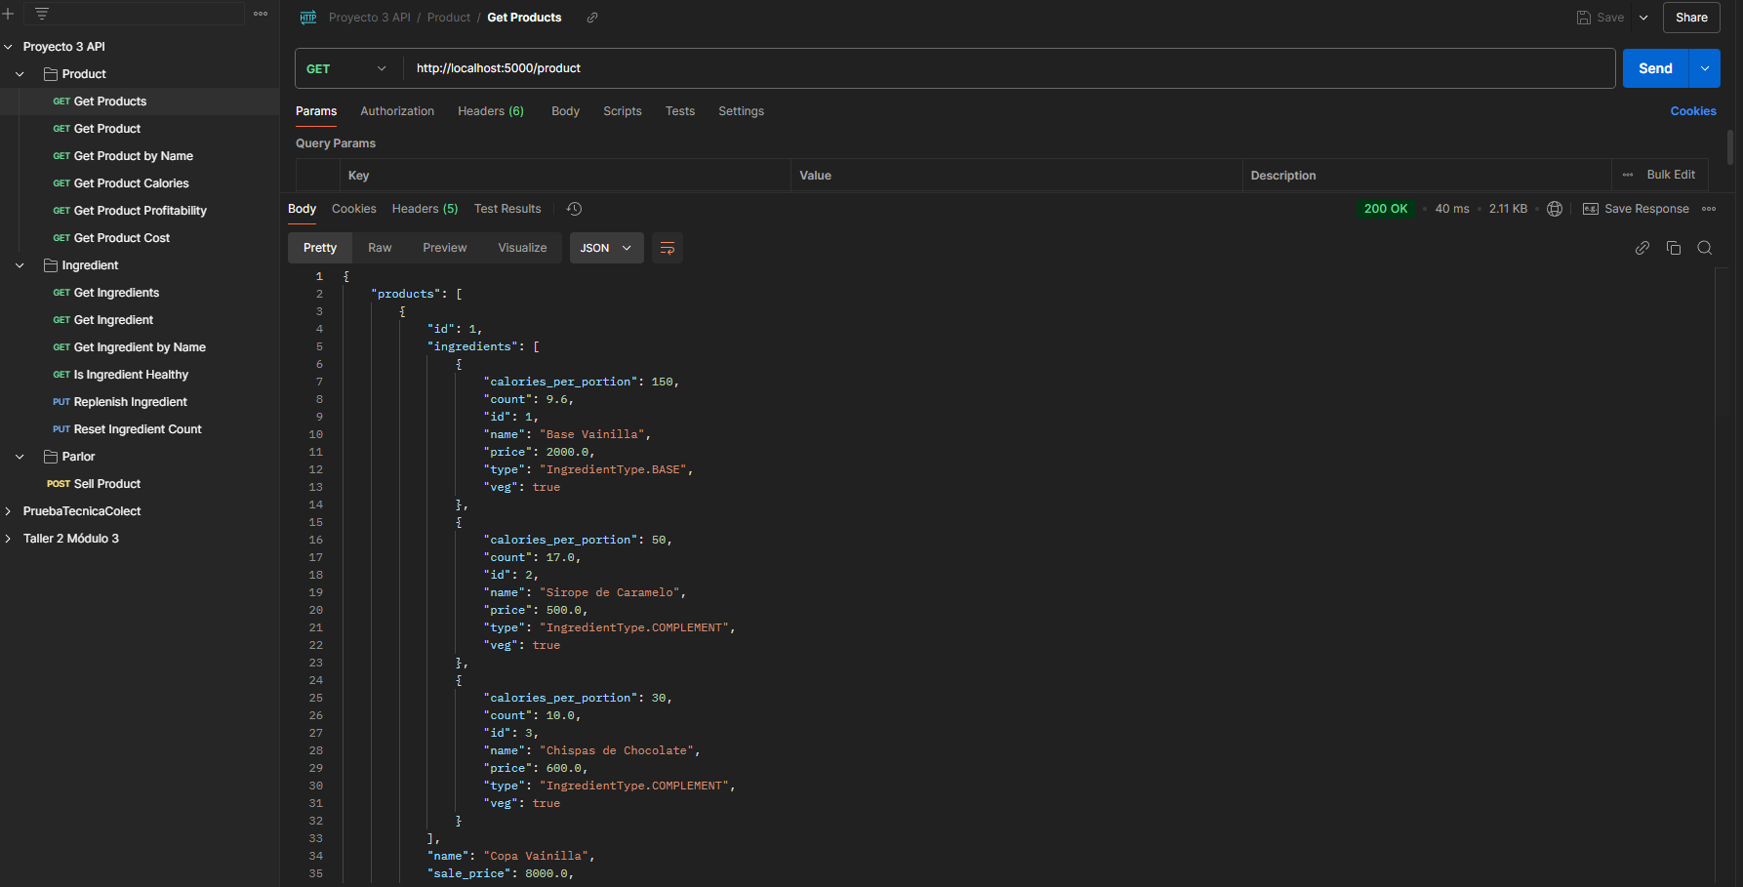

## Get Product

### Get Product by Name

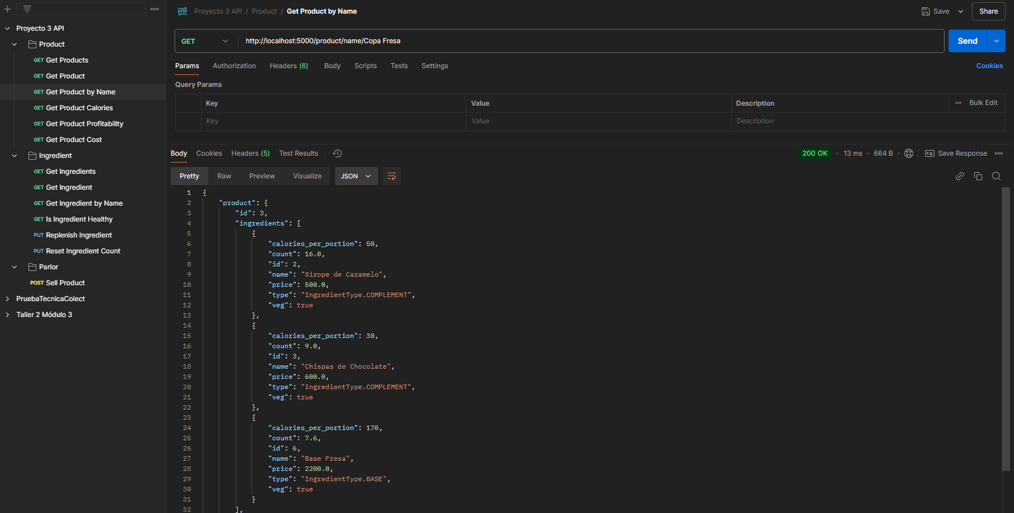

### Get Product Calories

### Get Product Profitability

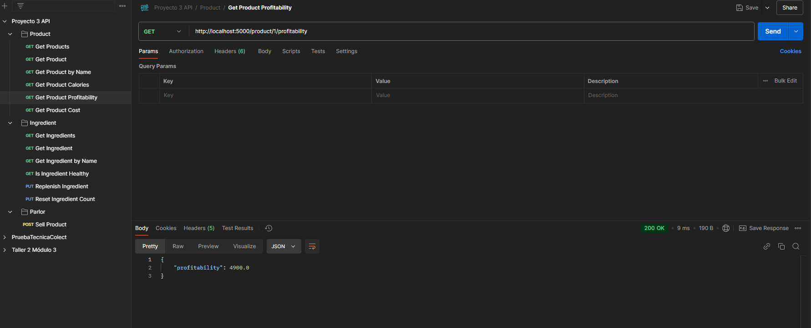

### Get Product Cost

### Get Ingredients

### Get Ingredient

### Get Ingredient by Name

### Is Ingredient Healthy

### Replenish Ingredient

### Reset Ingredient Count

### Sale Product

